CALDER VIEW SURGERY
NEWSLETTER
Issue 4 Winter 2017

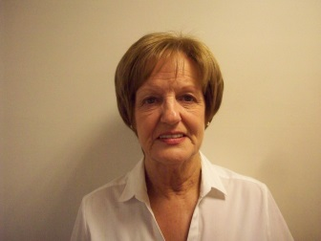
STAFF NEWS

A familiar face on our reception desk, Ann Hinchcliffe will be retiring in December after 22 years working for the practice.
Ann is hoping to go travelling during her retirement.

We wish her a long and happy retirement.

Rachel Fishwick will be joining us after Christmas as an Admin Assistant.

Amy Shaw has joined us as a trainee receptionist.

Julie Butler is a new practice nurse and commenced her post in November.

A Pharmacist, Bilal Patel is working with the practice 2.5 days a week. Bilal has worked in the community and for the CCG.

Dr Ahmed and Dr Shabir are helping to cover during Dr Taylor’s absence.

WALKING GROUP
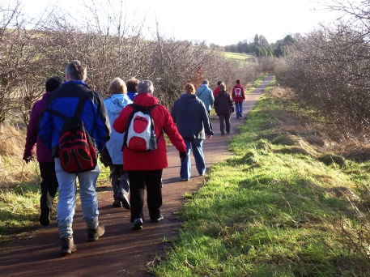

We are currently looking for someone to lead the walking group. This voluntary role would involve being available for a 2 hour period over Tuesday lunchtimes. You would need to attend a short training course. There is a small amount of paperwork involved. Please speak to Clare (Practice Manager) if you are interested. The Walking Group is a great way to improve your fitness whilst meeting new people.
READING WELL FOR LONG TERM CONDITIONS.
This is a book scheme which is being promoted by Kirklees Libraries. The books provide information and support for people living with a long term health condition, and their carers.
The booklist covers general advice and information about living with a long term condition, common symptoms and titles focused on specific conditions such as arthritis, bowel conditions, diabetes, heart disease, mental health and wellbeing and stroke.
The books have all been recommended by people with experience of long term conditions and health professionals, and are available to borrow for free from public libraries. Contact your local library for further information.

ART GROUP

Our Art Group led by Cassie Burton will in future hold the classes in a room at Dewsbury Library. The dates and times to be confirmed. If you are interested in joining the art classes, please give your name and details to a member of the reception staff.

FOOD FOR THOUGHT

“If the English Language made any sense a catastrophe would be an apostrophe with fur on…………………….and 'lackadaisical'
would have something to do with a shortage of flowers."
Doug Larson
We all know how difficult it can be learning another language. The English language is very irregular in its spelling and pronunciation so spare a thought for those currently struggling to learn it. Take a look at the following!

The bandage was wound around the wound
The farm was used to produce produce
The dump was so full it had to refuse more refuse
We must polish the Polish furniture
The soldier decided to desert his dessert in the desert.
Since there was no time like the present, he thought it was time to present his present.
When shot at, the dove dove into the bushes.
I did not object to the object.
Do you have a poem or short story that you would like to be considered for a future newsletter? If so please hand it in at the desk in an envelope clearly marked Newsletter or send it by email to dormor2700@gmail.com
Please remember to include your contact details.

The insurance was invalid for the invalid.
There was a row amongst the oarsmen on how to row.
They were too close to the door to close it.
The buck does funny things when does are present.
To help with planting, the farmer taught his sow to sow.
The wind was too strong to wind the sail.
Upon seeing a tear in the painting I shed a tear.
I had to subject the subject to a series of tests.

CHRISTMAS AND NEW YEAR

Please note that the surgery will be closed on December 25th, December 26th 2017 and January 1st 2018

If you need medical attention while the surgery is closed, ring the NHS non-emergency number which is 111.
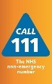
NHS 111 is the NHS non-emergency number. It’s fast, easy and free. Call 111 and speak to a highly trained adviser, supported by healthcare professionals. They will ask you a series of questions to assess your symptoms and immediately direct you to the best medical care for you.
NHS 111 is available 24 hours a day, 365 days a year. Calls are free from landlines and mobile phones.

A Big Thank You to everyone who supported our Coffee Morning at the flu Clinic in October. We raised £210 which has been presented to Dawn Thompson for the benefit of her daughter Lucy. Thank you also to all the bakers and those who helped on the day. Your Generosity is very much appreciated!

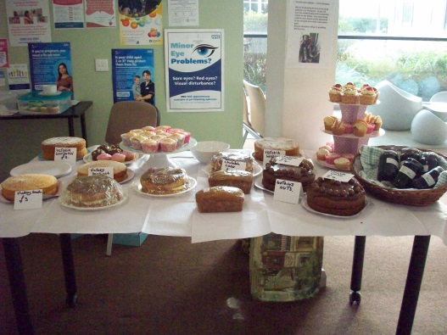

Happy Christmas to all our patients.

